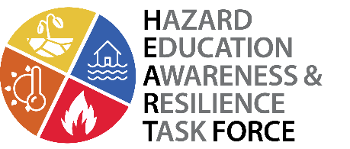
Resilient Southwest Teacher Workshop
Teach your students about resilience in Colorado and how to respond to natural hazards in your community.

We invite you to join Cooperative Institute for Environmental Sciences (CIRES) Education and Outreach, the Mountain Studies Institute, and local experts for a one-day professional development workshop to learn about hazards affecting Coloradoans; floods, wildfires, extreme heat and drought. Learn about the latest science and how to implement place-based curriculum in your classroom, including a scenario based role play game for the classroom.
WHO: Colorado Middle and High School Science Teachers
WHAT: Teacher Professional Development Course for content and curriculum based on new NGSS-based CDE Standards
- MS-ESS3-GLE9: Mapping the history of natural hazards in a region and understanding related geological forces
- HS-ESS3-GLE10: Natural hazards and other geological events have shaped the course of human history at local, regional, and global scales.
WHEN: Friday, August 9th, 8:30-4:30 PM
WHERE: Sunlight Room, Durango Community Recreation Center, 2700 Main Ave., Durango
COST: Free (8 Hours of Professional Development “Clock Hours”). If you are interested in Continuing Education Graduate credit (“semester hours”), up to 1 credit will be available through CU Boulder Continuing Education for a fee of $80.
Attendees will be offered an $80 stipend to cover the costs of their Continuing Education credits.
Note: HEART Force is funded by a NOAA Environmental Literacy Grant, and has an educational research component. Workshop participants will be asked to take a brief voluntary workshop evaluation pre- and post- survey.
Sign Up Here: https://resilientswpd.eventbrite.com
Registration Deadline: Friday, July 26th

