Mountain Studies Institute Citizen Science Forest Monitoring
Forests are dynamic ecosystems that respond to factors including water availability, fire, insects, diseases, climate changes and human management strategies. This project aims to involve citizens in monitoring those changes to our local forests. In particular, Colorado is experiencing widespread beetle infestations and large fires across forest types, from Ponderosa pine at low elevations to spruce fir forests in our highest mountains. Through scientific exploration, local citizen scientists can learn about beetle and fire cycles, and the broader connections between climate patterns, human management and forest health.

Objectives
- Empower citizens to research and engage with their local forest ecosystems
- Deepen the local understanding of the connections between forest health and water, drought, fire, insects, diseases and human activities
- Promote curiosity and the use of scientific methods to answer questions
- Collect baseline measurements of forest conditions

Directions
- Read this sheet and print relevant materials
  - MSI Citizen Science Forest Health Datasheet
  - Beetle identification sheet
  - Optional: beetle guides including the Spruce Beetle Quick Guide via the Colorado State Forest Service
- Navigate to the site based on directions from MSI
- Begin data collection
  - Fill out all fields at the top and data for each tree, with relevant notes to describe the plot
- Optional: complete additional Project Learning Tree forest assessments (wildlife, forest diversity etc.)
- Send data, including photos to jeremy@mountainstudies.org

Definitions

Location: Kendall Mountain, Molas Pass, Falls Creek or other
Observers: Classroom and students
Weather: general notes including sunny/cloudy/rainy, and temperature
Photos Taken: list directions taken from center (N, E, S, W, ground), or specific tree numbers for detail shots
Plot notes: anything of interest including animals spotted, a question about methods, or general impressions of the plot. Note seedling conditions here.
Tree Number: number on aluminum tree tag
Live/Dead: Does the tree seem alive (has needles) or dead (no needles)? Mark L or D
Needle Color: Are needles yellowing/dying? Estimate the percentage of the tree with dead needles. 1-10 scale 1=10%, 2=20% etc.
Insect/Disease Evidence: pitch tubes (sap/resin pouring from a beetle-drilled hole); boring dust (reddish sawdust produced when beetles bore in); exit holes (small holes created when mature beetles leave the tree); defoliators (caterpillars, webs, damaged buds, abundant moths); mistletoe (yellow, parasitic growth); Other? Note and take pictures if unknown
Burn Evidence: is the bark burnt? If so, measure or estimate the height of the char mark
Other Notes: anything that you want to share that helps us understand the data and health of a tree

Examples of Insect & Disease Evidence
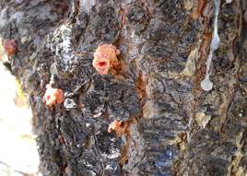
Figure 1: Spruce beetle pitch tubes

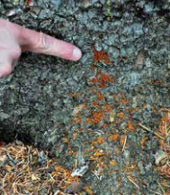
Figure 2: Spruce beetle boring dust
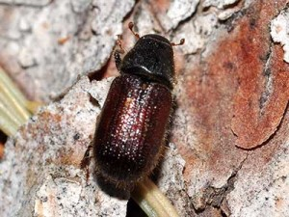
Figure 3: Spruce beetle

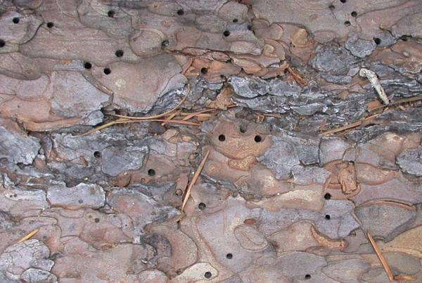
Figure 4: Pine beetle exit holes in Ponderosa Pine
Figure 5: Western spruce budworm caterpillar
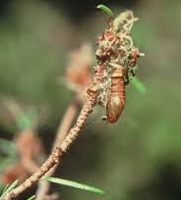
Figure 6: Western spruce budworm cocoon
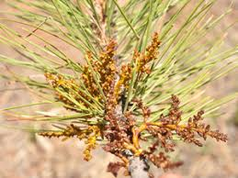
Figure 5: Dwarf mistletoe on Ponderosa Pine

