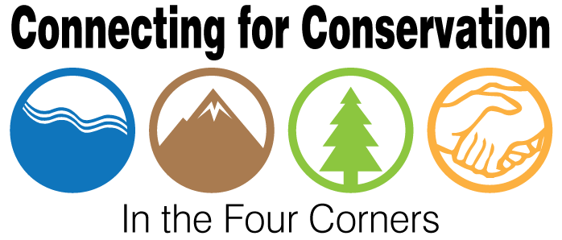

Mini-Workshop Notes
November 1, 2017
Fort Lewis College

Best:

- Networking & showcasing work
- Conversation/communication
- Speaking with a collective voice (rather than individuals), based on partnership/relationship
- Partnerships with mutual benefits and overlapping missions
- When an organization takes a risk or initiative it can ignite opportunity for other groups to engage or join in the effort or help steer it in the right direction
- Stretch and leverage funding (bringing in/identifying additional funding)
- Community, cross learning
- Sharing knowledge and perspectives
- Compromise- positive attitudes
- Building capacity- combining individual strengths
- Bringing together vendors, consumers, professionals and students at a “product fair” to network and showcase opportunities outreach to community
- Relationships with Mesa Verde National Park Mesa Verde curriculum for educators
- SCC and SJNF (local and regional)
  - Long term investment
  - Consistency
- Monitoring effort on Dolores in 2017
  - State- CPW
  - Non-profit- TNC
  - Federal- BLM, B of Rec.
  - Academia- FLC
  - Regional- DWCD
- San Juan Headwaters- FS
- Tribal forestry and BIA relationship
- Firewise- SCFS and Fire Departments
- BOR- working w/ conservation districts
- SME- NFF – mitigation program
- San Juan Forest Health Partnership
  - Scale/scope of focus area
  - Organized meetings
  - Grounded in forest ecology
  - Involvement w/ local high school
  - Citizen monitoring

Worst:

- Too much internal focus and not enough outreach – no external engagement
- Lack of commitment and follow through
  - Creates distrust, long term riff and damage to relationship
- Take time and effort – training high school interns
- Federal Funding – the timing and planning vs. budget allocation
- Meetings with no results
- Developing group visitation vs. individual
- Coming to the table not willing to compromise
- You know what YOU should do?
- Poor communication/inaction
- Need more diversity (tribal)
- Stagnation (same people, same ideas over and over)
  - Combat by engaging students and other fresh community voices
- Unhealthy competition with a partnership for credit/attention/funding
  - Leads to break-up/ bad blood
- Politics
- Lack of dissenter in long-standing group
- Tribal forestry= tribal understanding of mission
- Firewise= public understanding
- USGS= BLM relationship with mining area
- BOR= Conservation Districts
- SME= Agency reviews
- CPW and Trout Unlimited & USFS
  - Individual relationships work better than at the higher levels (agency to agency)
  - Chain of command – internal communication

Weirdest

- Need to understand organizational structure to capitalize on potential partnerships
- Partnership burnout – angered partners and ruined relationship
- Manure tea “probiotic for the forest”
- Your place or mine – meeting logistics
- Broad visions not based in reality – good intensions
- Two organizations try to partner only to find out there is no common goal
  - Could originate from uncertainty of missions/goals
  - Or lack of communication/focus
- Gravitate to easiest relationship

Issues

- Incorporating climate change info and other terminology into all partnerships/initiatives
  - Temporal and spatial scales
- Communicating partnership benefits to public/economic interests
- Organizational issues:
  - Who takes on these responsibilities – coordination and facilitation
- Who within organizations manages partnerships
- Money to help with communication

Opportunities

- Federal funding outlooks, budget implications
- Facilitated networking opportunities around issues
- Targeted experts to facilitate discussion
- Good knowledge exists about the impacts of climate change
- Emphasize importance of scale… temporal/spatial
- Increase visibility to public and increase effectiveness
- Incorporate the economic impact of work
- Catalogue/share failures – identify keys to success
- Recruiting non-traditional partners (e.g. Rio Grande Water Fund)

Needs

- Define partnerships
- Examples of group organization models (centralized vs decentralized)
- Define goals
- Avoid competing information
- Better communication platform
  - One webpage? Email network? Facebook?
- Searchable database to facilitate continued relationships/projects
  - Podio – professional network
- Partner opportunities w/ agencies, non-profits and for-profit agencies to cross economic and perception boundaries
- Streamlines contracting process to cross mission boundaries
- Ways to move these ideas up the food chain within agencies

Luncheon/Workshop topics & ideas

  - What are the funding steps?
    - Once need is understood – go to public or private first?
    - Do you go to other partners to find support/ideas?
- Are there new models for funding?
- How to determine who stakeholders are and how to get them involved
- How do you reach new audiences?
    - For involvement, engagement, funding
    - Consider schools
- Create or develop decision tree or template to understand and build most effective partnerships
- Tie between public health
    - Air quality
    - Water quality
    - Forest health
  - Need representation from health industry/ public health sector
  - Holistic community approach
  - Invasive species
  - Divide sessions into issue based topics
  - Let people communicate with each other/connect from different backgrounds
    - Public lands
    - Affordable housing
  - NETWORKING/collaboration
    - Agency people don’t get as much opportunity to “mingle”
    - Speed-dating and free-form time
    - Exercise to “force” people to collaborate
      - Group haiku of everyone’s interests
  - How to funnel funding to environmental education programs that support these larger project goals (watershed health, forest health etc.)
  - New avenues for environmental ed. (widening reach)
    - Private funding from places that wouldn’t otherwise be involved- corporations
    - Lunch time talks at large employers (teach adults!)
  - Everyone prepares a packet before may workshops to share
    - Bio, projects, potential projects
    - What kinds of partners they’re looking for
    - Citizen science opportunities

Other

- Partnership congestion (common theme)
  - Overlapping missions competing for funding and engagement
  - Geographical context
  - May be coming
  - # organizations/collaborations
  - funding
    - internal resources
    - time
    - people
    - values
  - Capacity to support all partners
  - Partners vs. stakeholders
  - Time*/staff
  - What’s the destination?
  - Who’s in the car?

- Partnership Model
  - Balance centralized vs. dispersed
  - Communication
    - Bring in new ideas
    - Conscience of the group

